The One Where No One Proposes
Written by: Sherry Bilsing-Graham & Ellen Plummer
Transcribed by: Eric Aasen
901 无人求婚
瑞秋认为自己同乔伊已订婚了, 而又不知这样是对是错。
于是向菲比倾诉，菲比还以为瑞秋说的是罗斯呢。
菲比向罗斯道贺，罗斯丈二和尚摸不着头脑。
乔伊想纠正错误，但又无从下手。
三人终于澄清事实后，乔伊离开，让罗斯和瑞秋陪着新生的女婴爱玛。
罗斯想和瑞秋重修旧好，不幸却意识到瑞秋已接受了乔伊的“求婚”。
莫妮卡和钱德在医院储藏室造小孩，被老盖勒撞见。老盖勒指出他们的姿势不利于生产下一代。
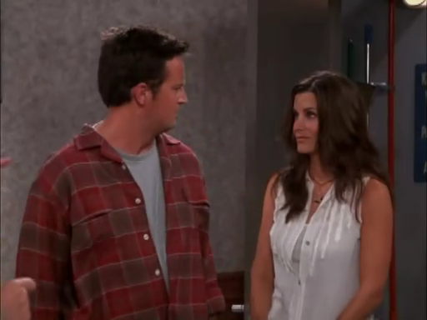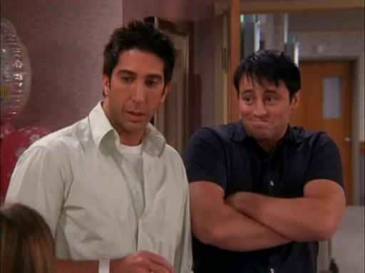
9.01 The One Where No One Proposes
Joey tries to tell Rachel that he didn't really propose, but can't get a moment alone with her.
Phoebe gets involved but that just confuses things.
Joey tries to keep Ross away from Rachel until he can straighten it out(v.澄清).
Monica and Chandler continue trying to get pregnant;
Mr.Geller discovers them having sex in the janitor's closet and is mortified(v.使丢面子), until he learns that they're trying to conceive;
then he's so enthusiastic he starts giving them advice, and Monica is mortified.
Joey, Ross, and Rachel finally straighten out that no one was going to propose;
Ross was just planning to ask Rachel if they could start up their relationship again.
Everything is just about smoothed out when Ross realizes that Rachel is wearing the ring, and therefore must have said yes to Joey[Scene: Rachel's Room, Joey moves Ross's coat to get the tissues Rachel wants and the engagement ring box Mrs. Geller gave him falls out of the pocket it was inside. Joey goes to one knee, picks up the box, opens it, and sees that it's an engagement ring.]
Rachel: Joey.
(He turns to face Rachel on one knee with the box open.)
Rachel: (seeing the ring) Oh my God. (Pause) Okay.
(Joey is stunned.)
[Cut to Ross getting off an elevator carrying a bouquet of flowers and walking down the hall to Rachel's room.]
[Cut back into Rachel's room.]
Rachel: So uh - I guess we should - make it official huh?
Joey: Uh - Look Rach - (Ross enters.) Hey Ross is here! Hey look! It's my good friend Ross. Hey Ross.
Ross: Hey Joey. (To Rachel) Hey you.
Rachel: Hey you.
Joey: Hey and look he brought flowers. Thanks Ross, but I'm really more of a candy kind of guy. (Laughs.)
Ross: You're weird today. (He turns to Rachel and Joey puts the ring back.) (To Rachel) Listen I uh, wanted to talk to you about something.
Rachel: Uh yeah, actually I kinda need to talk to you too.
Ross: Uh Joey, can you give us just a minute?
Joey: No.
Ross: What?
Joey: Oh, I'm sorry. I meant no.
Monica: (entering with everyone else including Mr. Geller) Hi! Hey look who's here!
Mr. Geller: Where's my granddaughter? I've been practicing my magic tricks.
Chandler: He pulled a quarter out of my ear!
Ross: Hey, where's uh, where's mom?
Mr. Geller: She went to pick up Aunt Liddy.
Monica: Oh, Aunt Liddy's coming? That means we get five dollars each!
Mr. Geller: So when do I get to meet Emma and show her this? (Pulls a bouquet of flowers out of his sleeve.)
Chandler: Okay. Wow.
Ross: Uh Dad, Emma's in the nursery. I'll take you now. If you want, but (To Rachel) I really want to talk to you.
Rachel: I know, I still need to talk to you.
Joey: Oh hey but, before you guys do that (To Rachel) I need to talk to you, and Ross, I need to talk to you.
Phoebe: (To Monica) Oh and I need to talk to you.
Monica: About what?
Phoebe: To see if you know what these guys are talking about.
Opening Credits
[Scene: Outside the Nursery, everyone but Rachel is standing and looking into the window.]
Monica: Isn't she beautiful?
Mr. Geller: Look at her, my first grandchild.
grandchild n.孙子 孙女
Ross: What about Ben?
Mr. Geller: Well of course Ben, I meant my first granddaughter. (To Monica, mouths) Wow.
Monica: God, isn't she beautiful? Doesn't she look just like Rachel?
Chandler: I know everybody keeps saying that, but all I see is Vin Diesel.
Vin Diesel (born Mark Sinclair Vincent on July 18, 1967) is an American actor, writer, director, and producer. Diesel is also the founder of the production companies OneRace Films and Tigon(n.虎狮) Studios. Diesel is distinguished by a shaved head, athletic physique(n.男子的体格), tell-it-like-it-is(n.实事求是) attitude, and a deep, textured(adj.有质地的) baritone(n.男中音) voice.
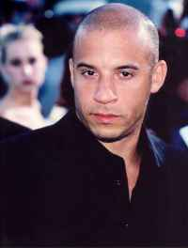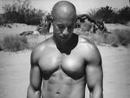
Monica: What do you think our baby will look like?
Chandler: Oh, God. Please You. But it'll have my sense of humor.
sense of humor n.幽默感
Monica: umm
Phoebe: (taking Ross aside) Have umm, have you thought anymore about you and Rachel?
take aside v.把…叫到身边
Ross: Oh well yeah, actually I was going to talk to her when you guys all came in the room.
Phoebe: Yay! It's so exciting! Wow, you could've done that with us there.
Ross: Yeah right.
Phoebe: Oh sure okay, you can touch yourself in front of us but you can't talk to Rachel.
Ross: What?! When have I ever touched myself in front of you guys?
Phoebe: Oh please! Just before when you were asleep in the lounge! That Armenian family was watching you instead of the TV. Oh, that reminds me that Mr. Hasmeje still has my Gameboy.
lounge n.长沙发/Armenian adj.亚美尼亚的/The Game Boy is a handheld game console developed and manufactured by Nintendo(n.任天堂), released in 1989 at $89.95 USD. The Game Boy was the first successful handheld console, and was the predecessor of all other iterations(n.反复) of the Game Boy line. The Game Boy was originally bundled with the puzzle game Tetris, since Nintendo thought that an addictive puzzle game would get consumers' attention.

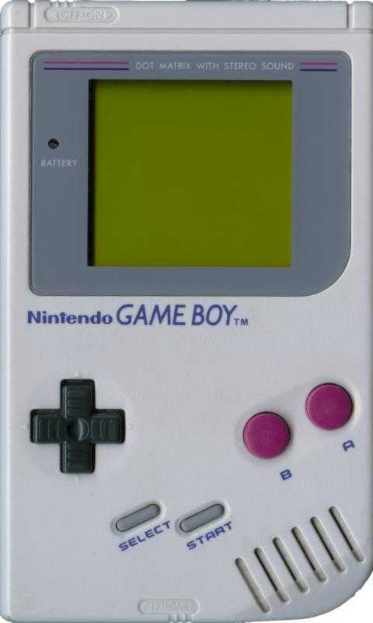
Joey: (taking Chandler aside) Hey Chandler, can I talk to you for a second?
Chandler: Sure.
Joey: Dude I just did something terrible.
Chandler: That was you?! I thought it was Jack!
Joey: No! No, that was Jack! Rachel thinks I asked her to marry me!
Chandler: What?! Why does she think that?
Joey: Because it kinda looked like I did.
Chandler: Again, what?!
Joey: Okay well, I was down on one knee with the ring in my hand -
Chandler: As we all are at some point during the day.
Joey: It wasn't my ring! It fell out of Ross's jacket! And when I knelt down to pick it up Rachel thought I was proposing!
kneel down v.跪下
Chandler: Ross had a ring?! And he was gonna propose?
Joey: I guess.
Chandler: And you did it first?! This is gonna kill him! You know how much he loves to propose!
Joey: I know! I know it's awful.
Chandler: Well, what did she say?
Joey: (happily) She said yes.
Chandler: You're smiling.
Joey: No, I'm not.
Chandler: Yes, you are. I can tell by the way your mouth is. Does Ross know?
Joey: Oh God, what the hell am I gonna tell him?
Chandler: Well maybe you don't have to tell him anything.
Joey: Oh, I like that. Yeah -
Chandler: If you clear things up with Rachel then Ross never needs to find out, but you have to do it now before he hears about it and kicks your ass!
clear things up with sb 和某人说清楚/hear about v.听说 获得消息
Joey: (laughs) Now let's not get carried away. (He walks away as Monica comes over and hugs Chandler from behind.)
carry away vt.使激动 使失去自制力[eg:The match was so wonderful that he was totally carried away]
Monica: I want a baby.
Chandler: Honey, we've been over this. I need to be facing the other way.
Monica: Come on! Come on, if we have sex again it'll double our chances of getting pregnant. Do you think that closet's still available?
Chandler: I'm so tired. (She starts kissing him.) Yeah okay, but no foreplay.
foreplay n.前戏
Monica: Deal!
[Back in front of the nursery window.]
Ross: Dad seriously! Y'know you really should see someone about that!
Mr. Geller: Noted.
well noted<俚>I know;I see好的 明白了
Ross: I wanna go talk to Rachel for a minute, are you gonna be okay alone for a bit?
Mr. Geller: Are you kidding me, I could stay and look at her forever.
Ross: (noticing something) Actually umm - (He turns Mr. Geller's head to look at Emma.)
[Scene: Rachel's Room, Phoebe is entering.]
Phoebe: Hey!
Rachel: Hi.
Phoebe: Are you all right?
Rachel: Uhh - I think I just got engaged.
Phoebe: Oh my God! He did it?
Rachel: Well - did you know he was gonna ask me?
Phoebe: Are you kidding? I'm like the one who talked him into it. I like to think of myself as the puppet master of the group.
take sb into sth 说服某人做某事
puppet master
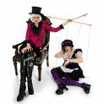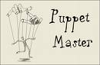
Rachel: And you really think this is a good idea?
Phoebe: I just talked him into it, don't tell me I have to do you too. The puppet master gets tired, people.
Rachel: I just don't know! It just doesn't feel right.
Phoebe: Why?! You two are so meant to be together, everybody thinks so.
Rachel: Really?! Even Ross?
Phoebe: Especially Ross!
Joey: (entering) Oh uh, hey Pheebs. Uh y'know what? I'll-I'll come back later. (He goes to leave but runs into Ross who's entering.)
Ross: Wow! Kind of uh, kind of a full house here. I'll guess just - I'll come back. (Ross exits followed by Joey.)
Phoebe: There he goes, your fiancee.
Rachel: I guess so.
Phoebe: Although he does play with himself in his sleep.
Rachel: I can't say that I'm surprised.
[Scene: A hallway, Joey and Ross find Mr. Geller with his ear up against a janitor's closet door.]
Ross: Dad, what are you doing?
Mr. Geller: I think there are people in there having sex.
(Ross turns to look at Joey.)
Joey: It can't be me, I'm standing right here.
Mr. Geller: Wanna peek?
peek v.偷看
Ross: No!
Mr. Geller: Come on!
Ross: Y'know what? I don't like you without mom. (To Joey) Come on. (Walks away.)
Joey: (To Ross) We're not peeking? (Follows him.)
Mr. Geller: Well I'm peeking. (He peeks.) Oh my God!
Chandler: Hello sir, you know Monica.
[Scene: Rachel's Room, she is taking the ring out of Ross's jacket, looks at it, and puts it on her finger as Joey enters.]
Joey: Hey uh, is it okay to come in?
Rachel: Of course! Oh Joey, this ring I - it's beautiful! I love it!
Joey: Yeah uh look Rach, there's something I gotta tell ya.
(There's a knock on the door and a nurse enters carrying Emma.)
Rachel: Hey!
Nurse: Hey! Are you ready to try nursing again?
Rachel: Yeah! Hi Emma. Hey, why do you think she won't take my breast?
Nurse: It's all right honey, it takes some babies a while to get it, but don't worry. It'll happen.
Joey: (watching) Yowsa! (Looks away.)
Yowsa<俚>an exclamation of surprise 噢哟
Rachel: Okay sweetie, you can do it. Just open up and put it in your mouth.
Joey: Dear Lord.
Rachel: I'm sorry honey, what were you saying?
Joey: Oh uh-uh yeah, I think that -
Rachel: Oh look, she's pulling away again! Do you think my nipples are too big for her mouth? (Joey gets embarrassed.) She looks scared. Doesn't she look scared?
pull away v.离开 脱身
Joey: Y'know, I don't really know her.
Nurse: Why don't we try massaging the breast to stimulate the flow. (Does so.)
Joey: (To God) Are you kidding me?!
Rachel: It's just so frustrating! Why doesn't she want my breast?!
Joey: I don't know! Maybe she's crazy! (Storms out.)
[Scene: The Lobby, Ross is eating a sandwich as Phoebe rushes up to him.]
Phoebe: Oh hey! Wait up!
wait up v.停下来等候
Ross: Hi!
Phoebe: Congratulations! I didn't want to say anything in front of Joey‘cause I didn't know if he knew yet.
Ross: What, that we had a baby? Come on let's give him a little credit, although he did eat a piece of plastic fruit earlier.
give sb credit 相信某人具有(某种 品德 才能等)/ealier adv.之前
Phoebe: No! No, that you and Rachel are engaged!
Ross: What?
Phoebe: Oh, it's a secret. Oh goodie! Yes! We haven't done the secret thing in a long time.
goodie int.<俗>好呀！
Ross: No, Rachel and I are not engaged.
Phoebe: I think you are.
Ross: What are you talking about? Who told you that?
Phoebe: Rachel, your betrothed.
betrothed adj.订婚了的 n.已订婚者
Ross: We're not engaged.
Phoebe: Oh, that's right. It's a secret.Okay, Right, you are not engaged. I misunderstood her.(blinks to him)
Ross: Phoebe, there is no secret. Okay? I didn't propose.
Phoebe: Are you lying? Is this like that time you tried to convince us that you were a doctor?
Ross: (pause) I am a doctor! Y'know what? I'm just gonna go and talk to Rachel myself.
Phoebe: All right, me too. (They go into her room and see that she's sleeping.) Should we wake her up?
Ross: No! No, come on let her sleep! She's so exhausted.
Phoebe: And so engaged. (Points to the ring that Rachel is wearing.)
Ross: What? (Motions for Phoebe to go outside with him.) Oh my God! She-she thinks we're engaged! Why? Why? Why would she think we're engaged?!
Phoebe: Perhaps because you gave her an engagement ring? Y'know Ross, doctors are supposed to be smart.
Ross: I didn't give her that ring!
Phoebe: You didn't?
Ross: No!
Phoebe: So whose ring is it?
Ross: It's mine.
Phoebe: Is it an engagement ring?
Ross: Yes!
Phoebe: But you didn't give it to her?
Ross: No!
Phoebe: But you were going to propose?
Ross: No!!
Phoebe: Huh, I might be losing interest in this.
lose interest in sth对某事失去兴趣
Ross: Look. Look, my mom gave me that ring because she wanted me to propose to Rachel, but all I wanted to do is see if she maybe - kinda - wanted ah - to start - things up again.
Phoebe: Oh, what beautiful lukewarm sentiment.
lukewarm adj.不够热心的 冷淡的[eg: lukewarm praise]/sentiment n.感情

Ross: Look, I didn't want to rush into anything. And it seemed like she didn't want to either. But I don't, I don't understand how any of this happened! What? Did she find the ring in my jacket, assume I was gonna propose, throw it on, and-and just start telling people?

rush into v.仓促行动
Phoebe: No! No, she said you actually proposed to her.
Ross: Well I didn't! I didn't propose! (Pause) Unless uh - (Pause) Did I? I haven't slept in forty hours and - it does sound like something I would do.
Commercial Break
[Scene: The Janitor's Closet, Chandler and Monica are trying to figure out what to do now.]
Chandler: Look, we can't stay in here forever.
Monica: Oh, I still can't believe my dad saw us having sex! He didn't make it to one of my piano recitals, but this he sees!
recital n.独奏会
piano recital
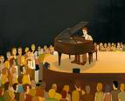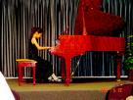
Chandler: This is okay. We're all adults here; there's nothing to be ashamed of. Now, let's put our underwear in our pockets and walk out the door. (They do so and find Mr. Geller leaning against a wall stunned.)
be ashamed of v.感到羞愧 惭愧
Monica: Hi Dad! I can still call you that right?
Mr. Geller: Of course. I'll always be your dad.
Chandler: I just want you to know that what you witnessed in there, that wasn't for fun.
for fun adv.开玩笑 不是认真的
Monica: It wasn't fun?!
Chandler: (To Monica) Why? Why-why-would you—Wh-why - (To Mr. Geller) Look, I just don't want you to think that we're animals who do it whenever we want.
Mr. Geller: Oh, I don't think that. Before today I never thought of you two having sex at all. It was a simpler time.
simple adj.简朴的 单纯的
Monica: The truth is, Dad, we're-we're trying.
Chandler: To kill you.
Monica: Why, why, why would you...?
Chandler: We're trying to have a baby.
Mr. Geller: What?
Monica: Yeah, we're trying to get pregnant.
Mr. Geller: Oh my God! This is so exciting! Well, get back in there! (Points to the closet) I'll guard the door!
Monica: Well, that's okay dad, we-we can wait until later.
Mr. Geller: Whoa-whoa-whoa! I don't think so! Aren't you ovulating?
ovulate v.排卵
Monica: Daddy?!
Mr. Geller: Well you gotta get at it princess! When your mother and I were trying to conceive you, whenever she was ovulating, bam, we did it. That's how I got my bad hip.
conceive vi.怀孕
Chandler: That's funny, this conversation's how I got the bullet hole in my head.
Mr. Geller: This one time I had my knee up on the sink and your mother, she was –
sink n.水槽
Chandler: Seriously, sir, my brains, all over the wall.
Monica: Daddy! I don't think we need to hear about the specific positions you and mom had sex.
specific adj.详细而精确的
Mr. Geller: You're right, you're right. This is about your positions. Now, what I saw in the closet is not the optimum position for conceiving a child, although it might feel good.

optimum adj.最理想的 最适宜的
Monica: I don't feel good right now.
Mr. Geller: But pleasure is important, (To Chandler) and it helps if the woman has an orgasm. You up to the task,sailor?
orgasm n.性高潮/sailor <俚>What hookers often call a potential customer.
Chandler: Oh, my God....(wipes his forehead with underpants)
[Scene: Rachel's Room, Monica is entering.]
Monica: Hey.
Rachel: Hey. I need to tell you something.
Monica: Well, now's a good time. I'm on my way to have my ears cut off.
be on one’s way v.濒临
Rachel: Joey asked me marry him.
Monica: What?
Rachel: Joey proposed to me.
Monica: Is he crazy?! You just had Ross's baby!
Rachel: Well, I-I said yes.
Monica: What?! Are you crazy? You just had Ross's baby!
Rachel: I'm sensing you won't throw the shower?
shower n.为新娘或即将分娩的妇女等举行的)送礼会
Monica: It's-it's so inappropriate. No, it's worse than that. It's wrong. It's - It is bigger than mine! (Rachel's engagement ring.)
Rachel: I know. Days of Our Lives, thank you very much.
Monica: You can't marry him!
Rachel: Why not? I don't want to do this alone! And he's such a sweet guy and he loves me so much.
Monica: Well do you love him?
Rachel: Sure.
Monica: Sure?
Rachel: Yeah, I mean whatever.
Monica: If you're worried about breaking his heart again, it's still broken from the last time. So really, you're just taking the already broken pieces and breaking them into smaller, more manageable pieces. Okay, forget that.Honey, the question is - do you really want to marry Joey?

manageable adj.易处理的
Rachel: No. No, I don't. Could you be a dear and go tell him?
dear n. (常作称呼)亲爱的(人)[eg: You're a dear to help me do the work]
[Scene: A Hallway, Chandler is following Joey.]
Chandler: You still haven't told Rachel you weren't really proposing?
Joey: No! She had the ring on, she seemed so excited, and then she took her breast out.
Chandler: Joey, you have to tell her what's going on! And what did it look like?!
Joey: I didn't look at it. Stupid baby's head was blocking most of it.
Chandler: Go and tell Rachel right now before Ross finds out.
Joey: Look, it's not that easy. She said she wanted to marry me. I don't want to hurt her.
Chandler: Okay, look, just do it gently.
Joey: You're right. You're right. I-I'll go tell her now before Ross finds out and I'll be gentle. I can do that. I am a gentle person. Oh, by the way. Two people screwing in there (Points to the closet Chandler and Monica were in) if you want to check that out.

screw <俚>have sex
[Scene: Rachel's Room, Ross is entering.]
Ross: Hey.
Rachel: Hey.
Ross: Listen, I um - I heard about the engagement.
Rachel: Surprised?
Ross: And confused. Rach, sweetie, I-I um - I didn't propose to you.
Rachel: I know.
Ross: I don't think you do.
Rachel: You didn't propose to me. Joey did.
Ross: Poor baby, you're so tired. Rach, I didn't propose to you, Joey didn't propose to you, and Chandler didn't propose to you.And Chandler didn't propose to you.
Rachel: Uh - You didn't propose to me, Chandler didn't propose to me, but Joey did.
(Joey enters.)
Ross: Joey proposed to you?
Joey: I can come back.
Ross: Hey, wait! Wait-wait-wait! Joey, did you propose to her?
Joey: No.
Rachel: Yes you did!
Joey: Actually, technically, I didn't.
Rachel: Well then why did you give me a ring?
Ross: Wait! Whoa-whoa, you - you gave her the ring?
Joey: No! No, and I did not ask her to marry me!
Rachel: Yes, you did!
Joey: No, I didn't!
Rachel: Yes, you did!
Joey: No, I didn't!
Rachel: Yes, you did! And don't you say, "No, I didn't!"
Joey: Ahhh!
Rachel: He was right there. He got down on one knee and proposed.
Ross: Whoa! You were down on one knee?
Joey: Yeah. Yeah, that looks bad. But I didn't - I didn't propose!
Ross: Then what did happen?
Rachel: Yeah, what did happen?
Joey: Okay, the ring fell on the floor and I went down to pick it up and you thought I was proposing.
Rachel: Yeah, but you said, "Will you marry me?"
Joey: No, I didn't!
Rachel: Yes, you did!
Joey: No, I didn't!
Rachel: Yes, you did—Oh my God you didn't! (Screams) Well then why didn't you tell me that before?!
Joey: Well I tried, but people kept coming in and then you took your breast out!
Ross: Whoa! Hey! Whoa-whoa-whoa, you saw her breast?!
Joey: (To Ross) I'll tell you about it later. Be cool.
Rachel: Well then Joey, what the hell were you doing with an engagement ring?!
Joey: It wasn't my ring! It's Ross's ring! That's why I felt so bad Rach, because he was going to propose.
Ross: What?!
Rachel: You were gonna propose to me?
Ross: Uhh - No.
(An awkward silence follows.)
Joey: Well, this is awkward.
Ross: But I-I was going to see if y'know, maybe you uh, start dating again but that - I mean that-that was all, Rach.
Joey: Dude, step up! I proposed.
Ross: No, you didn't!
Joey: Oh that's right. There's a lot going on here and I think I ate some bad fruit earlier.
Rachel: All right, so let me just get this clear. You didn't propose.You weren't gonna propose.So this morning, I didn't have a boyfriend and somehow I got dumped twice today.
(There's a knock on the door and the Nurse enters carrying Emma.)
Nurse: Hey, she just woke up! She's hungry. Why don't we give this another try?
Rachel: Okay.
Joey: Here we go again.
Ross: (To Joey) I can't believe you told her I was gonna propose!
Joey: I can't believe you're not gonna propose!
Ross: Hey, I'm not gonna rush into anything!
Joey: Oh yeah, dude, I totally understand. Usually after I have a baby with a woman I like to slow things down!
Rachel: Oh my God!
Ross: What?
Rachel: She's doing it Look, she's breast-feeding look!
Joey: (looking at the ceiling) Ah, it's beautiful.
Nurse: I'll come back for her later.
Rachel: Okay.
Ross: Thank you. (The nurse exits.)
Rachel: Oh wow, this feels weird.
Ross: Good weird?
Rachel: Wonderful weird.
Joey: Y'know what you guys? I'm uh, I'm gonna go too. And uh, I'm sorry about everything.
Rachel: Honey don't worry, it was my mistake.
Joey: No, Rach, I should've told you sooner. It's just that - Man! That kid is going to town! (Joey makes his awkward exit.)
go to town<俚>vigorous sexual activity[eg: He kissed her a few times, then they really went to town]
Rachel: She's perfect.
Ross: We're so lucky.
Rachel: We really are.
Ross: Look, I-I know it's not a proposal and I don't know where you are, but with everything that's been going on and with Emma and - I've been feeling -
Rachel: I know. I know. I'm feeling
Ross: Yeah?
Rachel: Yeah. (Laughs nervously)
Ross: Okay, well, that - Wow, okay, well, umm - then maybe, at least we can, we can talk about us again.
Rachel: Yeah, maybe.
Ross: Well good, okay. I-I, kind of think y'know if we - if - you're wearing the ring....
(Pause.)
Rachel: Wh-what's that?
Ross: And you told Phoebe you were engaged.
Rachel: I'm sorry, what?
Ross: When you thought Joey proposed,did - did you say yes?
Closing Credits
[Scene: Outside the Janitor's Closet, there are people having sex and Mr. Geller is trying to give them some pamphlets.]
pamphlet n.小册子
Mr. Geller: Kids, I spoke to a doctor and picked up this pamphlets on how to get pregnant. (He slides them under the door.)
Monica: (walking by with Chandler.) Hey dad!
Chandler: Hey.
Mr. Geller: (pause) Sorry to bother you again, but could you pass my pamphlets back? (They do so.) Thank you.
End

